# Week2 Queries and results

1. SELECT DISTINCT(employee_info.Manager_ID),employee_info.Last_Name, employee_info.Email AS 'Employee Email'

FROM employee_info;

Result:

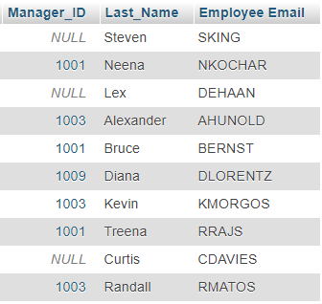

1. SELECT CONCAT(customer.First_Name, ' spent about ' ,sales.Sale_Amount) AS 'Sales info’

FROM customer,sales

WHERE customer.Customer_Email=sales.Customer_Email;

Result:

